**The Legendary Mozart**

**——A Music Game**

**Executive abstract:**

The Legendary Mozart is a level based music game, combining the legendary life of Mozart in the story of the game. The user can enjoy three game modes, including exciting story mode, challenging ZEN mode, and relaxing pure music mode. Through this fun and educational game experiment, the player can get known of the classic music and life story of Mozart. The game will be developed as a desktop application, utilizing the developng tool such as Unity, Magicavoxel and so on. The final product will be able to approachable for users of all ages, with a smooth and exciting game experiment.

**Motivation:**

Music education has not been paid enough attention to for a long time, which makes students lack the basic knowledge and interest of classic music. Much worse, people tend to listen to classic music less and less, partly because of its slow rhythm and recondite theory. Considering this situation, we are interested in developing a fun music game to help people start to enjoy the beauty of classic music. We believe that the most important part of a game is its exciting playing experiment, and then the player will naturally get interested in background story and art. And the music game is a perfect game form for performing classic music and the story of Mozart. The playing itself can be interpreted as the Mozart playing piano, with his music as background music. With these advantages, we believe our final product will be highly entertaining and educating.

**Team:**

胡圣然，曹畅，艾君达，李文博，周文迪

**Feature Description:**

One of our biggest feature is that the Mozart music game is oriented to all age groups. Since people in the society are of different ages, having different cognitions and attitudes toward things, say game, music, life, etc. As a result, people’s demands for a game varies. Under this circumstance, a game performs well if it can adjust to various demands.

In order to elucidate our game’s advantage in all-age-adapt, here we provide 4 typical user stories representing 4 use cases.(Notice: the use case diagram is shown in our PPT)

**Use Case 1**

Consider a kindergarten girl whose name is A. She is 6 years old and of the age to learn about the world. Since classic music is thought to be beneficial to people out of various music styles, A’s mother want to cultivate her interest for it using Mozart game. As A is too young to understand Mozart’s career, her mother can choose “Replay” mode to cultivate her sense of rhythm, or choose “Enjoy” mode to teach her knowledge of classical music.

**Use Case 2**

Consider a middle school boy whose name is B. He is 16 years old with heavy study load and he wants to play games in his spare time. As a middle-school-age boy is able to play with complex games and is in an important period to learn things. B mainly has 2 choices, one is to upgrade and learn experience as a development game, gaining fun and sense of achievement, the other is to have a deeper knowledge of Mozart.

**Use Case 3**

Consider a mid-year man whose name is C. He is 30 years old and is a busy office clerk with heavy work load. Sometimes, he wants to relax by listening to some music. So he can choose “Enjoy” mode to get relaxed. But sometimes, he wants to do some challenging things to let out his pressure. So he can choose “Zen” mode to challenge Boss.

**Use case 4**

Consider an elderly woman whose name is D. She is 65 years and gest retired. During these days, her children is worried about her health. Since D’s memory is decreasing, she might suffer from Alzheimer which is a horrible disease. Under these circumstance, her children let her play Mozart game to help her prevent Alzheimer since this is a fast-paced game which can improve people’s responsiveness. Also, she can choose “Enjoy” mode to enjoy music.

**Requirements:**

**Functional Requirements**

*General Goal:* A stand-alone musical game that runs on Windows desktop.

**Restraints**

• Memory cost

• CPU cost

• Financial cost

• Duration requirement

**Game Modes**

• Story mode: Player can experience the legendary and vivid life of the great composer Mozart.

• Zen mode: Designed for the music game geeks, provide players with excitement of fighting in highly difficult situation.

• Purely enjoy mode: Provide a nice place to enjoy the graceful classical music.

**Non-functional Requirements**

*General Goal:* Easy to get on and appeal to people cross age, culture and gender.

• Great music collection

– Respecting the historical facts

– Highly distinguishable, iconic composes

• Intuitive, beautiful, smooth UI and UX

– Beautiflflul patterns, layout, and font

– Instant feedback

**Game Flowchart:**

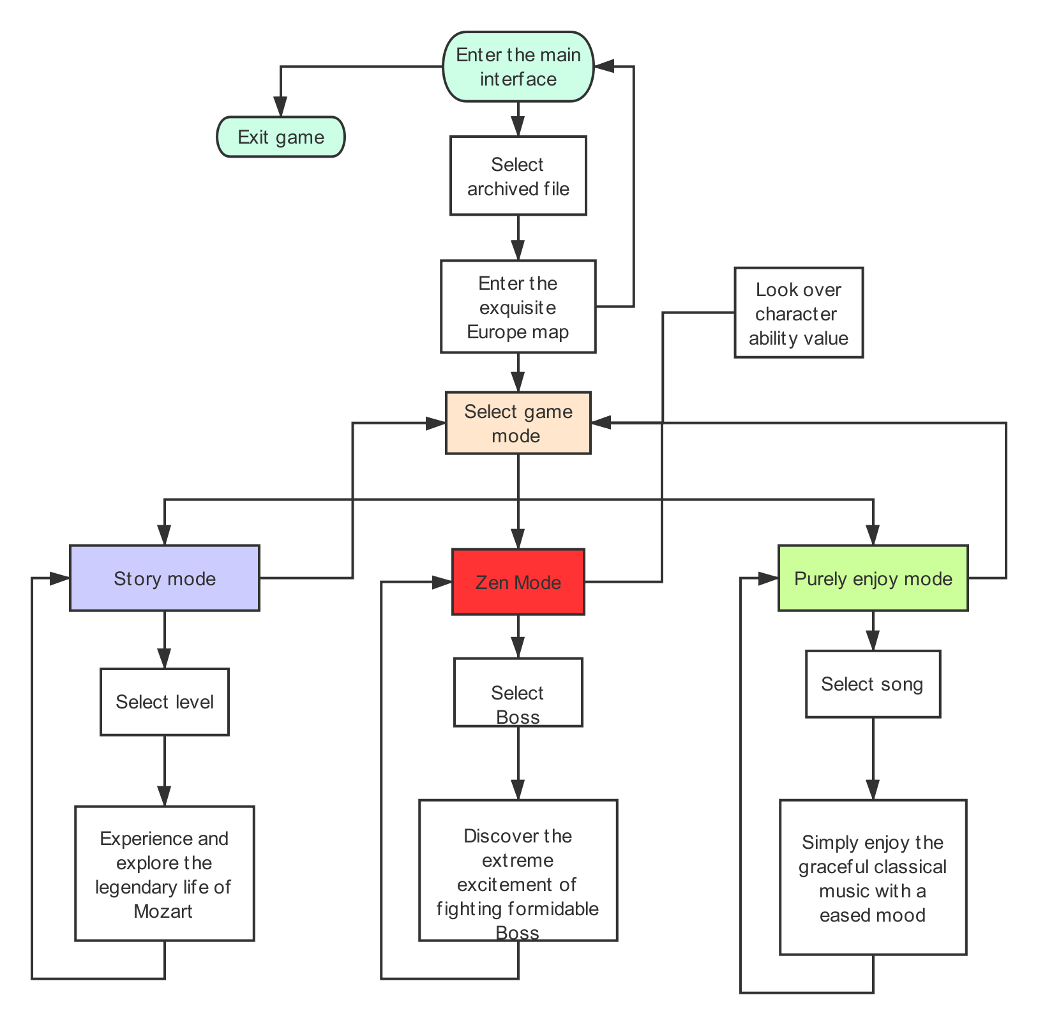

**API and techniques may be used in our game:**

**Map-making, 3-D modeling:** MagicaVoxel

**UI,Art design:** Photoshop, Procreate, Omnigraffle etc.

**Database:** mySQL

**Logic design, Programming:** Visual Studio etc.

**Music Score design:** FL Studio

**A preview of game mode selection interface:**

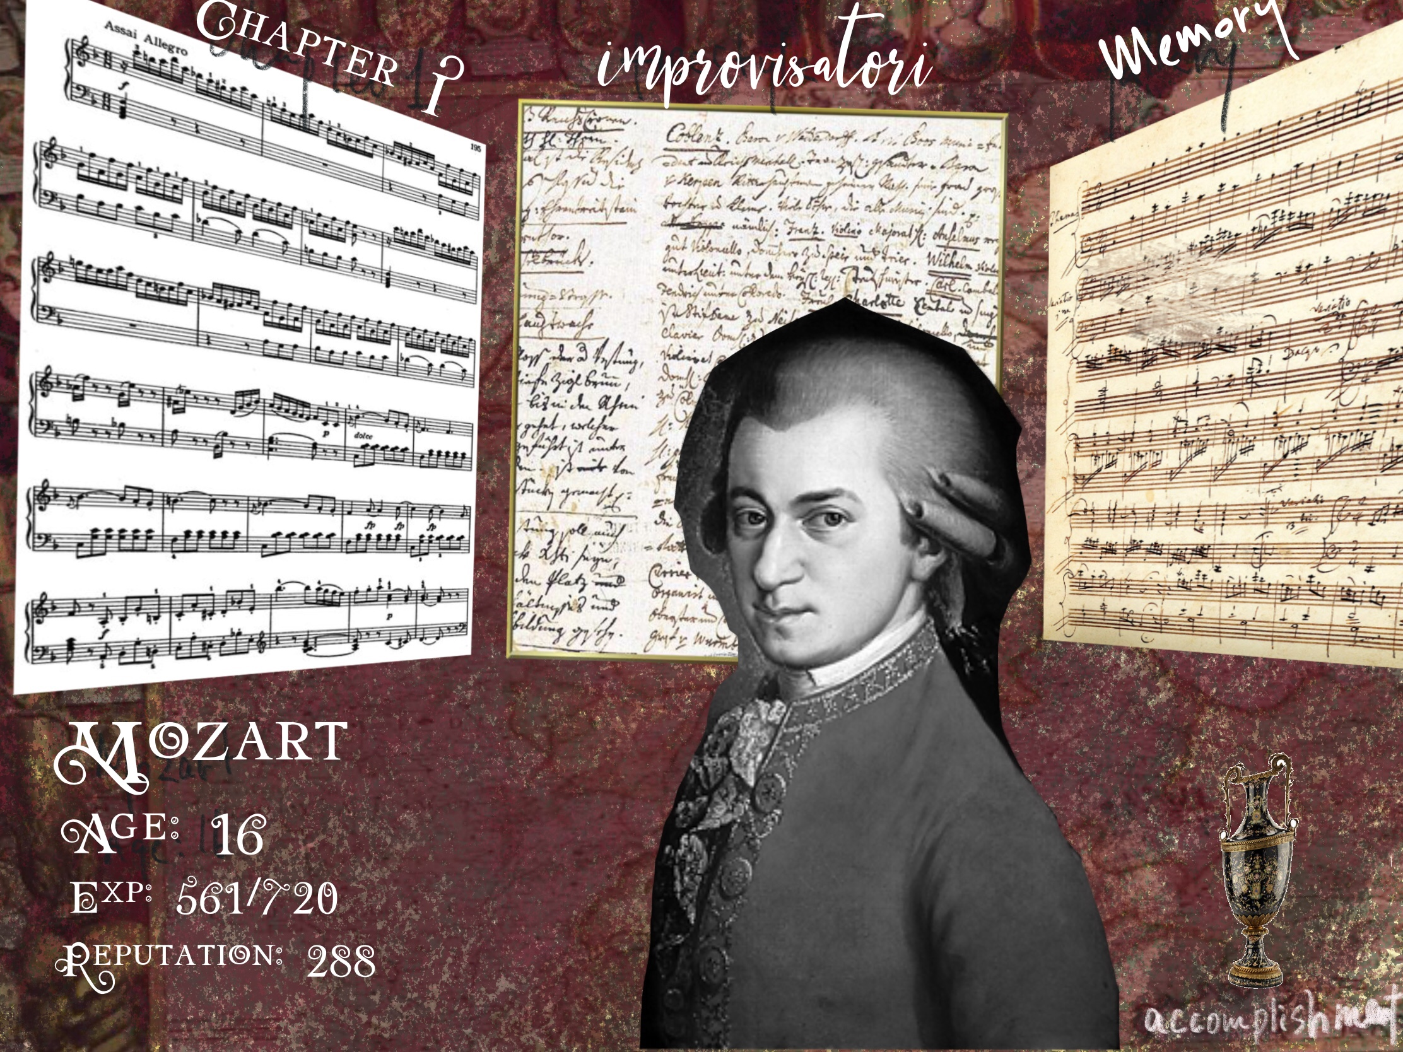

**Song selection interface:**

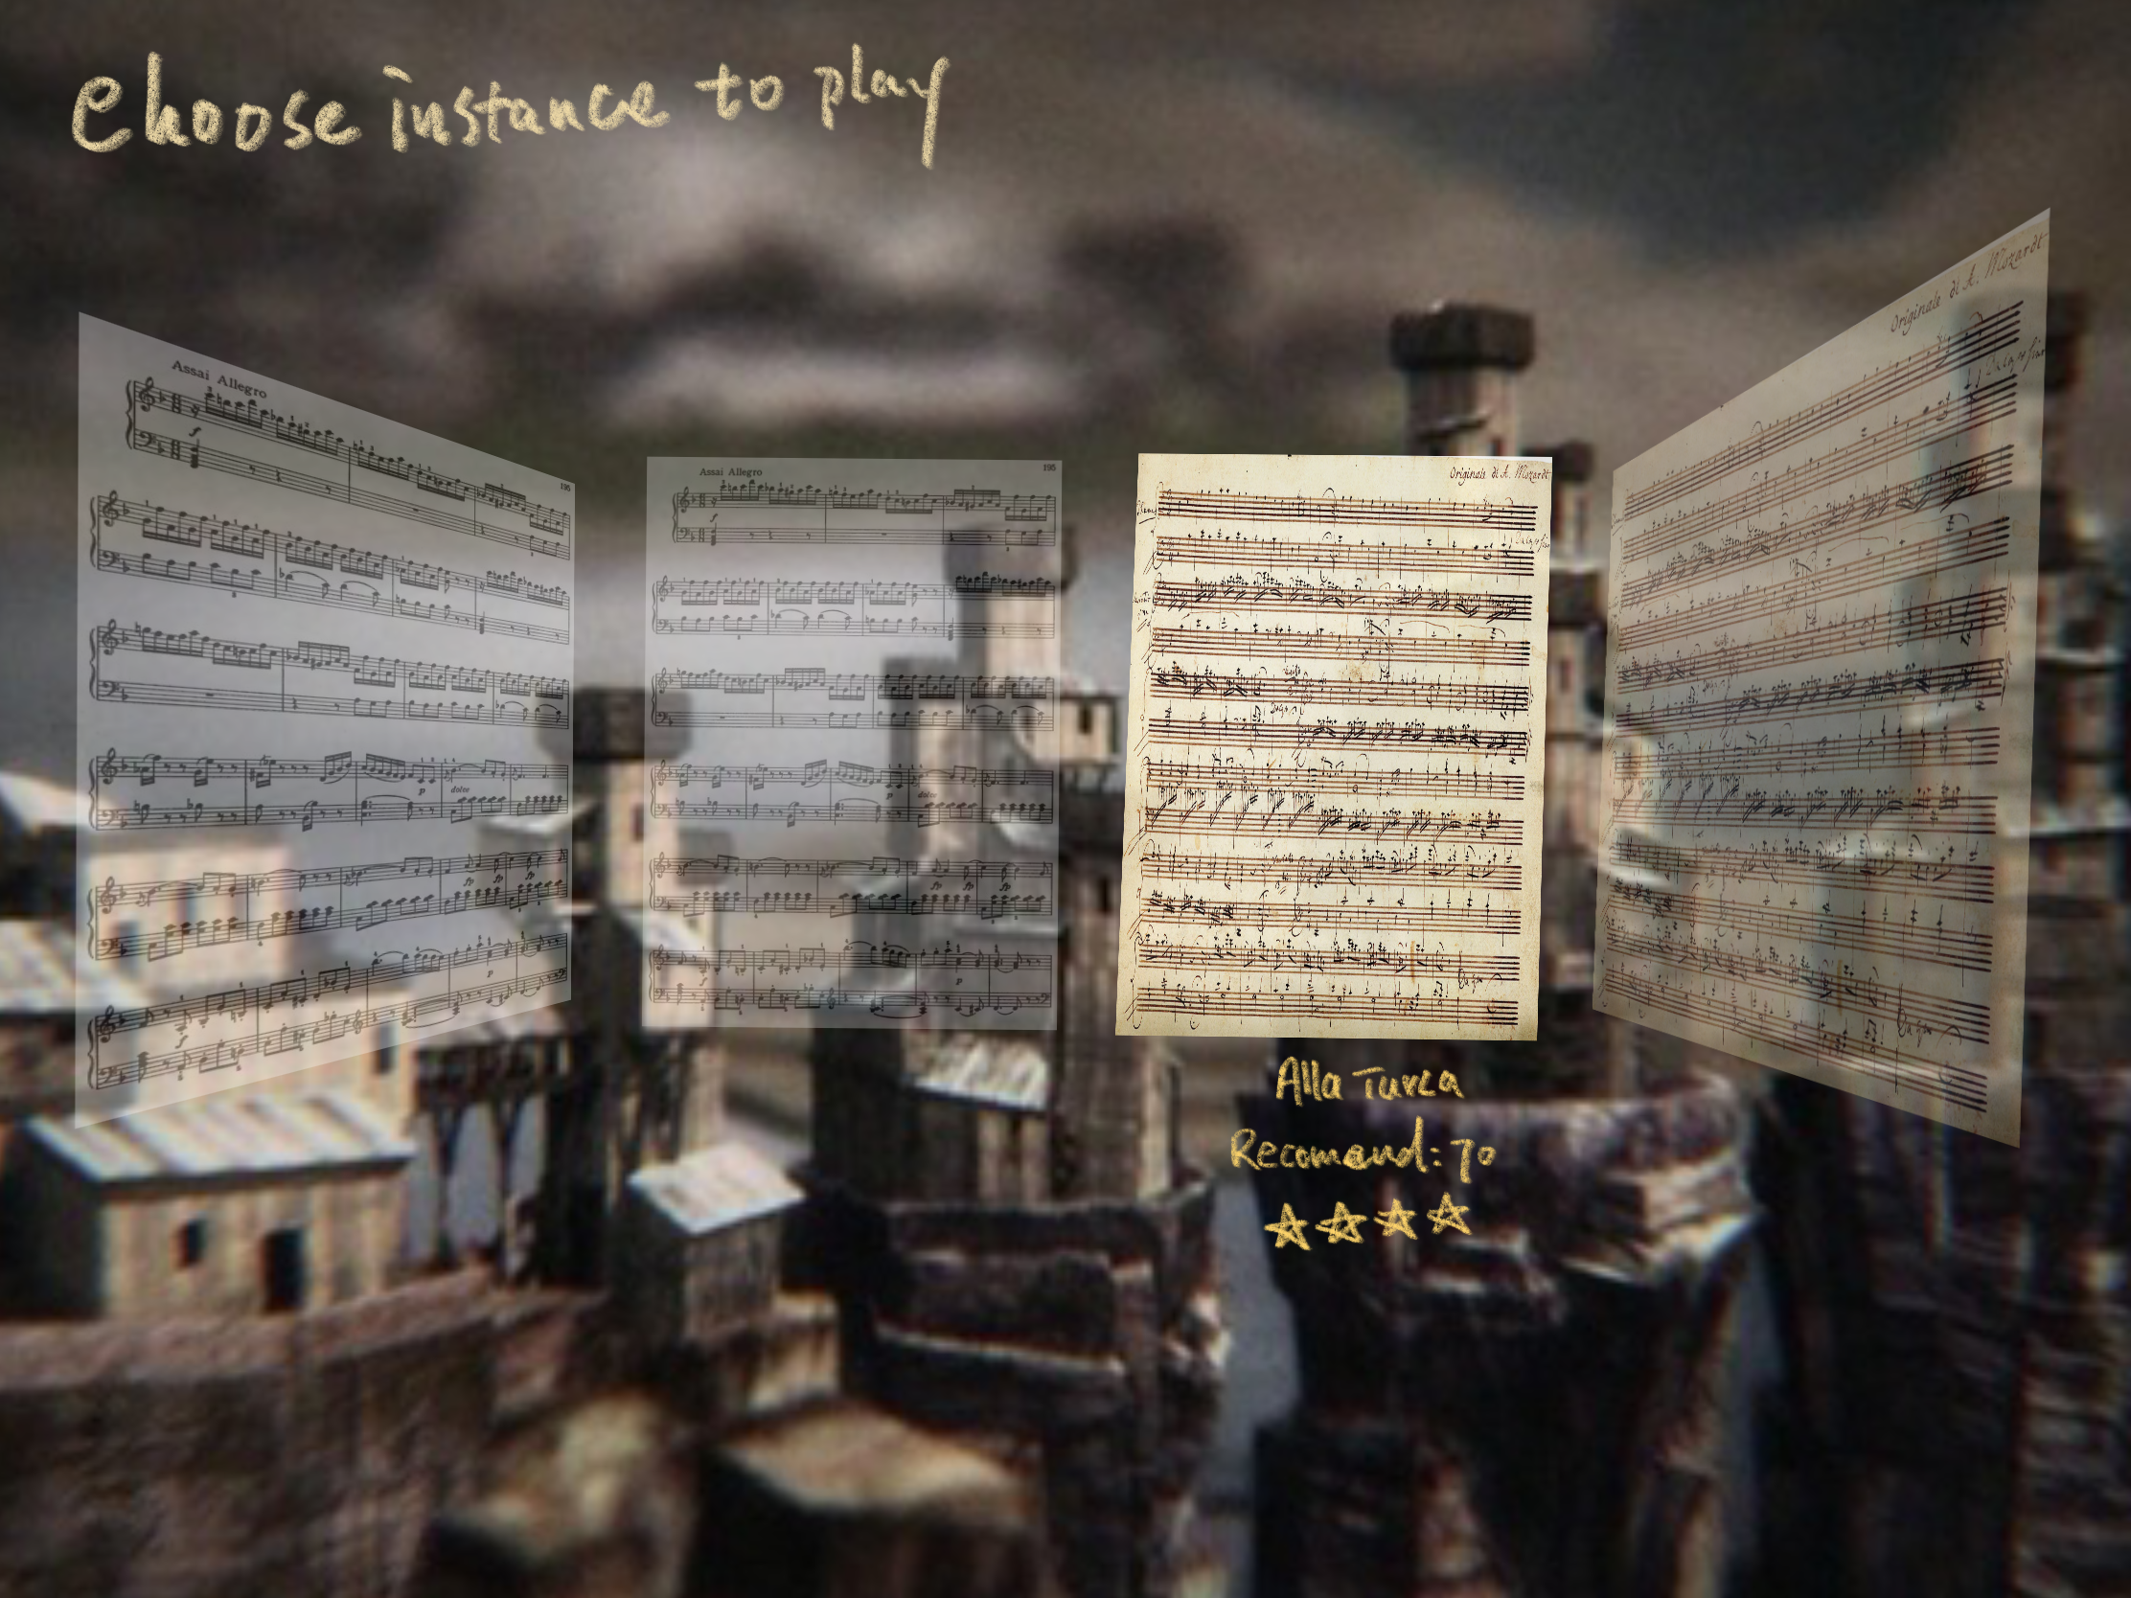

**Timeline:**

Our timeline is shown as follow:

* 10.7 determine the overall schema of the game
* 10.13-10.21 implement the basic functions for a music game
* 10.24- 11.8 rest for about 2 weeks, prepare for mid-term exams
* 11.9-11.15 implement the basic UI-design, implement the function of displaying game story and plot, have a new discussion about the game balance and design.
* 11.16-11.22 Finish all the basic functions of the game, launch our first runnable demo
* 11.23-11.29 Append new game instances, melody, CG, stories and maps
* 11.30-12.6 Polish new game instances, melody, CG, stories and maps.
* 12.7-12.13 Testing, debug, improve user experience etc.
* 12.13-12.22 Finish off, prepare for our presentation.

During the national holiday we have some discussion about our overall expectation towards this game as a team. We discussed the possible way of implement this game and found a solution to combine Mozart’s life story and his work into a game together. We also decided the APIs and game engine etc.

Then in the first stage we will began to implement the game in unity, first we need to implement the basic functions of a music game, the functions that enable user to play a game with some background music (for example, hitting keyboards according to some rhythm).

Then we also think it may be unrealistic to have heavy workload during the midterm exam weeks, and we decided to have a-week-break and focus on our mid-terms.

After mid-term we need to implement the basic user interface, at that time, maybe some of the function will haven’t been implemented, but we should have a demo that looks like a game. And we also need to introduce the story of Mozart into the game, we may use a simple gal-game form to tell the story. At this time, the basic form of the game is almost finished, we need to add more RPG features into this game, so we need to have discussion towards character’s health, reputation and other parameters like this to maintain the balance and keep the game as something fun to play.

By the middle of the November we should have our first playable demo. We should implement all the functions we want to for this game, including (story mode, boss mode, memory mode) three playing mode, (we may give up the some feature if we find the workload too heavy later).

Near the end of November and the beginning of December, we need to add more content into our games, like more stories, CG, characters, bosses, maps, music pieces etc. We’ll try to enrich the meaning and playability. We basically are doing polishing in this stage.

During most of the time in December we’ll do testing and debug, to make sure the game can function normally, we may also try to solve some problems we remained in previous stages. We may also add some feedback feature trying to improve user experiences.

Hopefully before Christmas we can finish the whole project and prepare for our presentation. And concentrate on our final exams after that!

**Feasibility：**

1. Implement a game need high quality art. We can make the art ourselves but it may also be extremely time consuming.
   1. We may pay for some artists to do some art for us. But we may possibly exceed our budget since it’s limited.
   2. We kind of decided to use some art-style that’s simple and not that time-consuming
   3. We may give up the quality of the art a bit, if necessary
2. Most of our group member don’t know Mozart very well.
   1. We may watch the movie Amadeus together when we have leisure time.
   2. We can use some help from Central Conservatory of Music
3. We don’t know much about music, our game may not be a very outstanding music game
   1. We can use some help from Central Conservatory of Music
4. We are not very familiar with Unity, 3D modeling, music composition
5. We have designed many features, and we are not very sure about the workload since we don’t have experience before. If the workload is too heavy, we may give up some of the features.